Jennifer Stegina

25 September 2019

CIS 250

**CIS250 Final Exam**

For each question, fill in one SQL statement, and a screen shot of the output. Please paste the answers below the questions in this document.

Good Luck!

1. Using the course table, find all the courses that cost less than the average course price. Show description, course_no, and cost in your results. Order by cost in descending order. Make sure your cost is in $9,999 format <Hint: Use the to_char statement to format your answer>

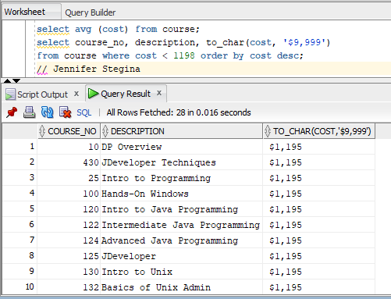

1. Using the course and section tables, list all the courses and their corresponding sections. Show course_no, description, cost, start_date_time in your results. Order your results by course_no, then description. Make sure that your course_no, description, and cost do not duplicate in the display of your results.

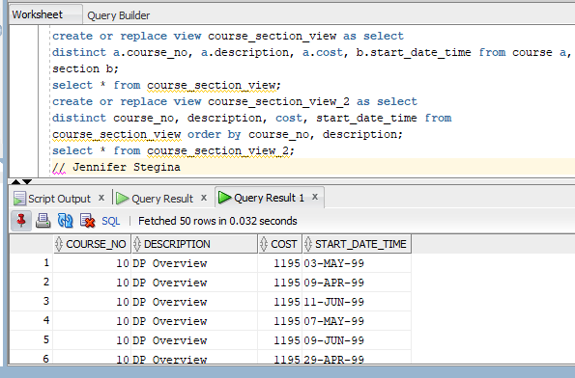

1. Using the zipcode and instructor table, show all the zipcodes and the count of instructors that live in those zipcodes.

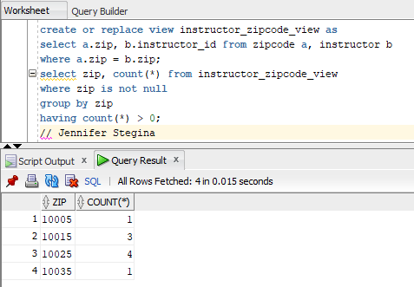

1. Using the zipcode and student table, show all the students that live in Brooklyn. Show student_id, first_name, last_name, street_address, state, and zip in your results. Order your results by last_name, then first_name.

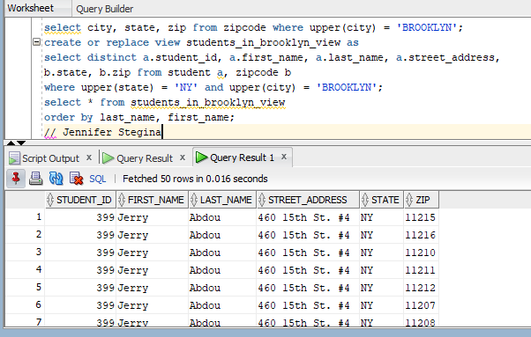

1. Using the instructor and section table, list all the instructors and the number of sections they teach. Show first_name, last_name, and the number of sections they teach. Order your results by the number of sections in descending order.

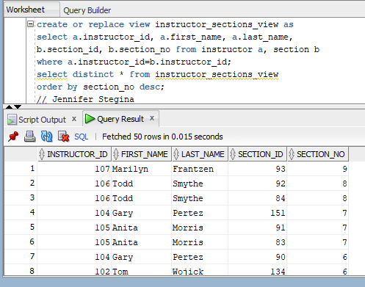

1. List all the students who live in the same zipcode as the instructor Tom Wojick. Show first_name, last_name, street_address and zip in your results.

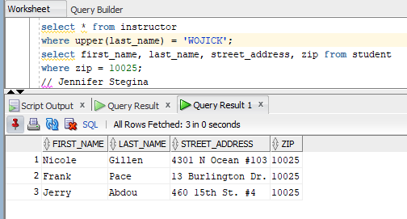

1. List all the students who registered before Vera Wetcel. Show student_id, salutation, first_name, and last_name in your results.

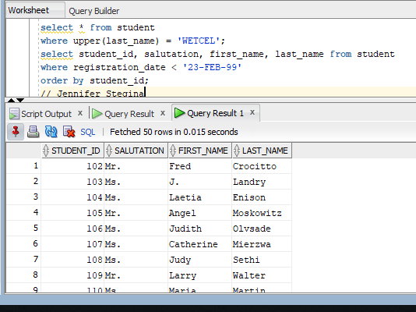

1. Using the student and enrollment table, find all the students who haven’t enrolled in any classes. Show student_id in your results.

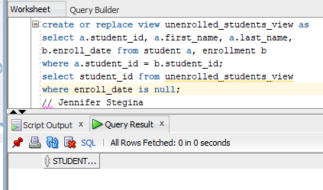

Trick question – according to the student and enrollment tables there is not anyone that is not enrolled in at least a single class.

1. Create a view called all_people_view that lists all the students and instructors currently present at the university. Show salutation, full_name, street_address, zip, phone in your results. The full_name column should be the “first_name last_name” columns from the tables.

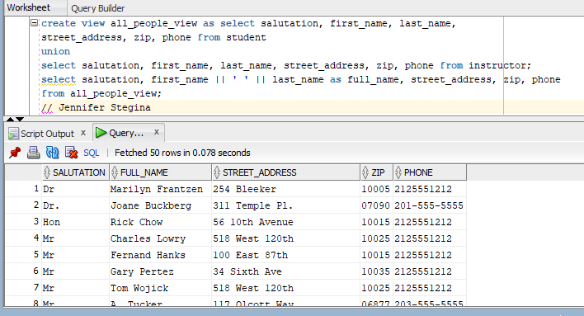

1. From the enrollment and student tables, show the student who got the highest grade. Show first_name, last_name, and student_id in your results.

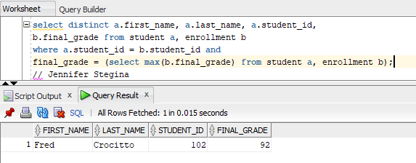

1. Using the course, section tables, list all the courses who have more than 5 sections. Show course_no, description, and number of sections.

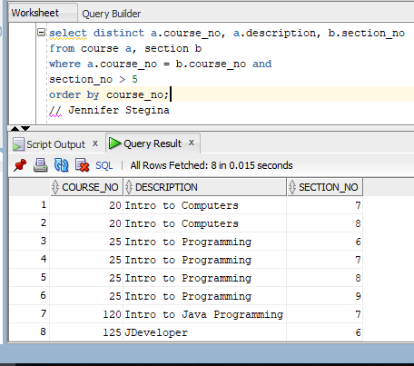

1. List all the courses and their prerequisites (if any). Show course_no, description, cost of the course, and course_no, description of the prerequisite.

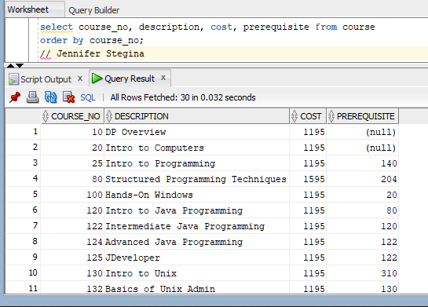

1. List the course(s) who have the most sections. Show course_no, description, and number of sections in your answer.

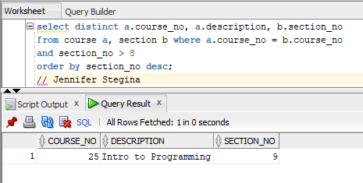

If you want the top 3 values

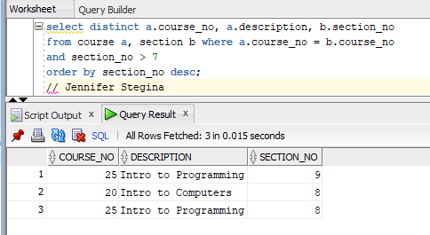

1. Using the course, section, and enrollment tables list all the courses that have more students enrolled than their capacity allows. Show course_no, description, start_date_time, capacity, and current number of enrolled students in your results.

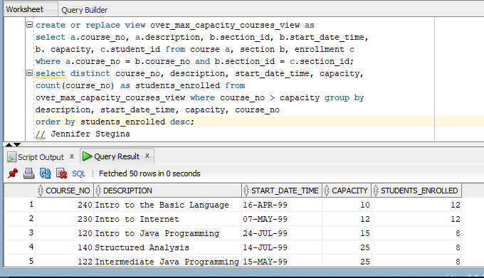

Rest of answer below

